**Facing the sun**

[array](http://www.practice.geeksforgeeks.org/tag-page.php?tag=array&isCmp=0)[searching](http://www.practice.geeksforgeeks.org/tag-page.php?tag=searching&isCmp=0)[Amazon](http://www.practice.geeksforgeeks.org/tag-page.php?tag=Amazon&isCmp=1)

An array of buildings is facing the sun. The heights of the building is given in an array. You have to tell which all buildings will see the sunset.

**Input:**

The first line of input contains an integer T denoting the number of test cases.  
The first line of each test case is N,N is the number of buildings.  
The second line of each test case contains N input H[i],height of building.  
  
**Output:**

Print the total number of buildings which will see the sunset.  
  
**Constraints:**

1 ≤ T ≤ 100  
1 ≤ N ≤ 500  
1 ≤ H[i] ≤ 1000  
  
**Example:**

**Input:**  
2  
5  
7 4 8 2 9  
4  
2 3 4 5

**Output:**  
3  
4

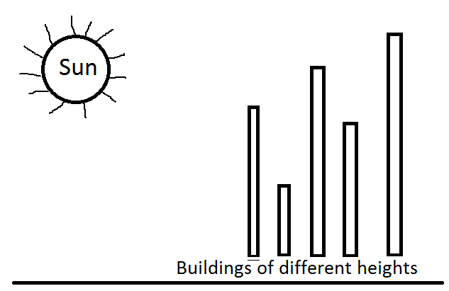

**For More Examples Use Expected Output**

<http://www.practice.geeksforgeeks.org/problem-page.php?pid=515>

#include <iostream>

#include <stdio.h>

#include <vector>

#include <map>

#include <string.h>

#include <math.h>

#define ll long long int

using namespace std;

int main() {

int t;

scanf("%d", &t);

while(t--) {

int N;

scanf("%d", &N);

int H[N];

for(int i =0; i<N; i++) {

scanf("%d", &H[i]);

}

int max_build =0;

int cont =0;

for(int i =0; i < N; i++) {

if(H[i] > max_build) {

max_build = H[i];

cont ++;

}

}

printf("%d\n", cont);

}

}